**How to run Python code on Google Colaboratory**

Google provides Jupyter Notebook like interface to run Python code on online Virtual Machines.

**Step #1:** Open <https://colab.research.google.com/>

**Step #2: Sign in with your google account**

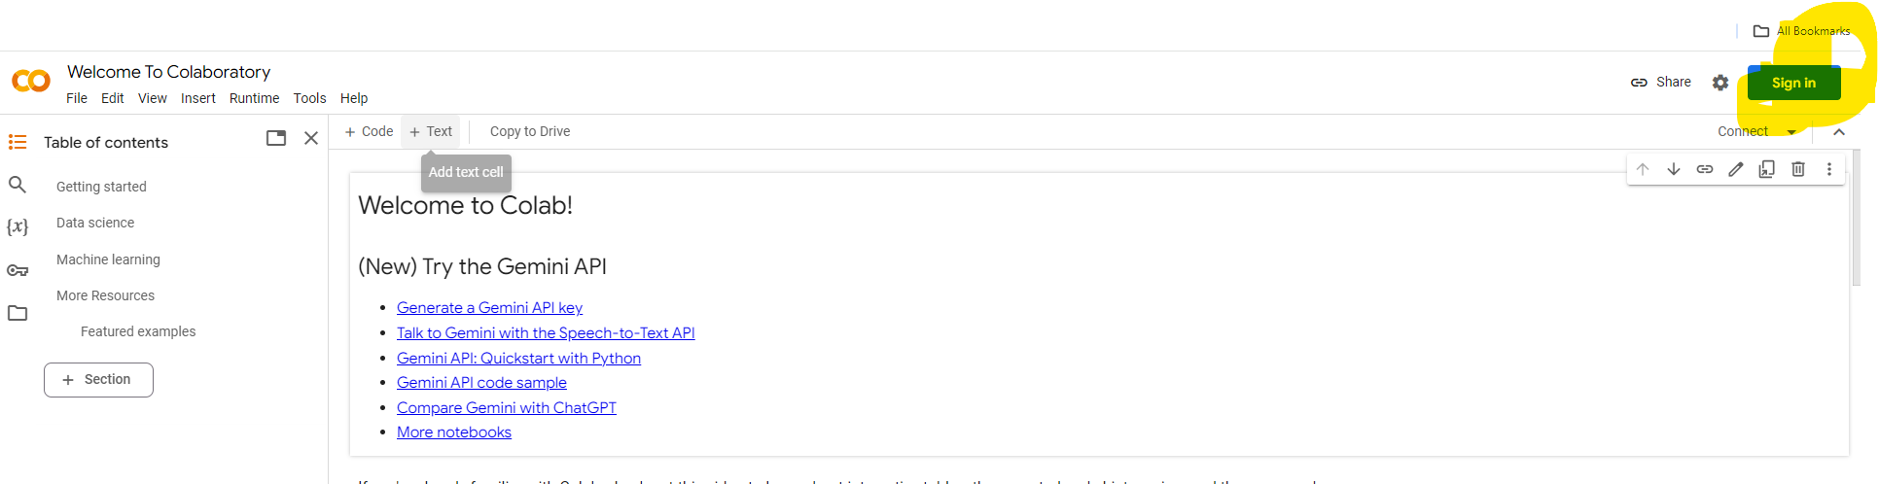

**Step #3 :**  Open new notebook [once you signed in a window will open, go to the bottom left and select “New Notebook”]

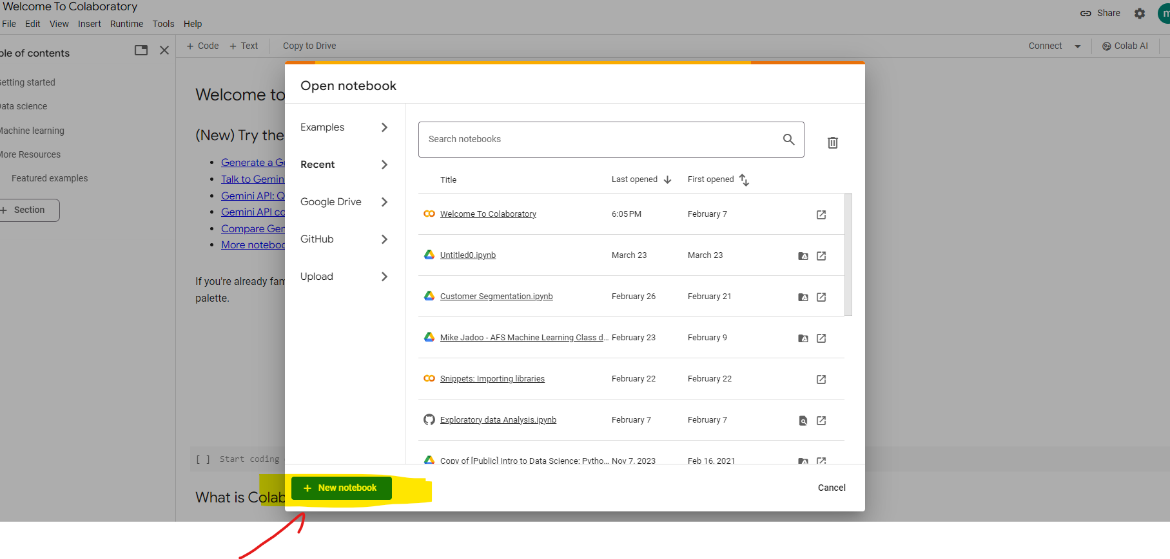

Step # 4: You are ready to code in Python

